

bule hora university

COLLEGE: - INFORMATICS



November 9, 2023

BULE HORA UNIVERSITY

Submitted to: - Mr. Diriba A.

|  |  |  |
| --- | --- | --- |
| No. | Group Members | ID |
| 1 | Kawoto Bogale | Ru1848/12 |
| 2 | Awol Seid | Ru0820/12 |
| 3 | Yohanis Zekarias | Ru0932/12 |
| 4 | Kano Tafese | Ru0644/12 |
| 5 | Kamil Ahmedin | Ru1172/12 |

Department: - Computer Science and Engineering

Course Title: - Image Processing

Course Code: -CsEg5191

Group Assignment

**1, Entertainment and gaming industry in image processing**

The entertainment and gaming industry utilizes image processing to enhance visual effects, create realistic graphics, and improve gaming experiences.

Image processing techniques are used for tasks such as rendering 3D models, applying textures and lighting effects, motion capture for realistic character animations, and image recognition for augmented reality games.

These technologies contribute to immersive and visually stunning experiences in the entertainment and gaming industry.

**1.1, Entertainment and image processing**

The entertainment industry uses image processing to enhance visual effects in movies, TV shows, and other forms of media. Image processing techniques are used for tasks such as compositing multiple images, color correction, and removal of unwanted objects from the scene.

Image processing is widely used in the movie industry for Visual Effects (VFX), Color Grading, Restoration and Remastering, Motion Tracking, and Facial Recognition. It helps create stunning visual experiences and preserve classic films.

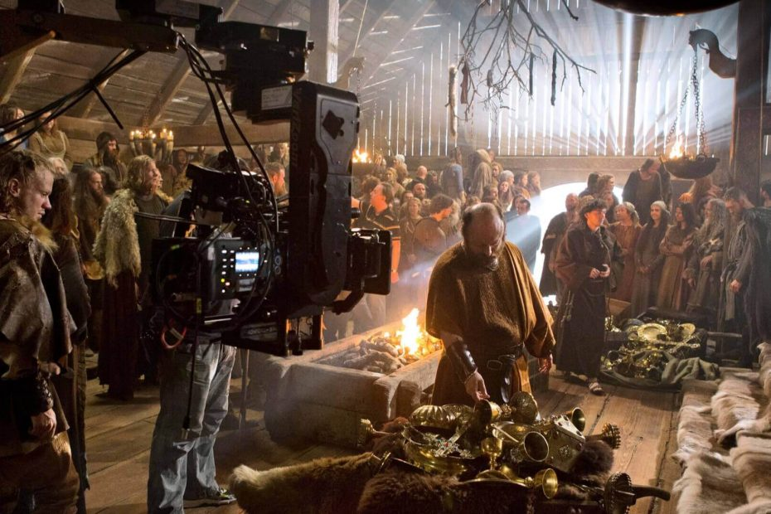

Figure 1: Film industry, in action.

**How does image processing work in entertainment?**

In the entertainment industry, image processing involves the manipulation and enhancement of images to create visually appealing and realistic effects. Here's a simplified overview of how image processing works in entertainment:

1. Capturing or creating images:

Cameras: Cameras play a crucial role in capturing real-world images that form the basis of movies, television shows, and other forms of media. Cinematographers and directors of photography use various techniques to capture the desired visual elements, such as camera angles, lighting, and framing.

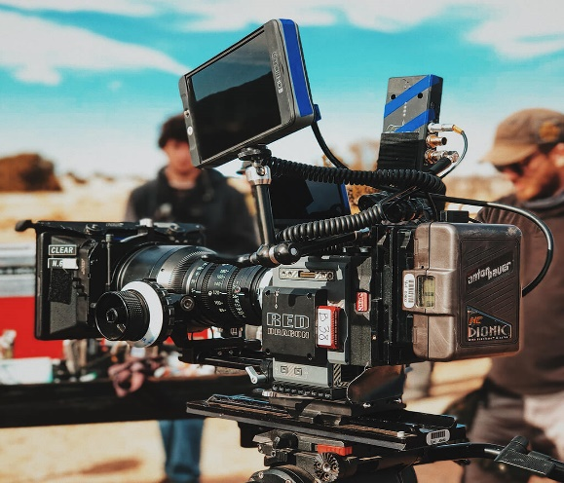

Figure 2: Red Dragon camera for capturing a high-quality image

Computer-generated imagery (CGI) is used to create virtual environments, characters, or objects using 3D modeling and animation software. This allows filmmakers and game developers to create stunning visual effects that would be impossible to capture in the real world.

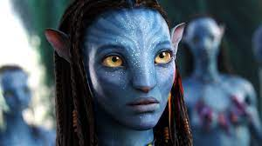

Figure 3: Example of the computer-generated image

1. Pre-processing:

Before applying specific effects, images may undergo pre-processing steps such as noise reduction, color correction, and image stabilization to improve their quality.

Noise Reduction: Cameras can introduce noise into images, particularly in low-light conditions. Image processing algorithms can be used to remove this noise, resulting in a cleaner and more visually appealing image

Color Correction: Color grading is a common image processing technique used to adjust and enhance the colors of movie footage or television shows, giving it a specific look or mood. This can include adjusting brightness, contrast, saturation, and other color parameters to create a desired effect.

Image Stabilization: Cameras can introduce unwanted motion into images, resulting in shaky footage that can be difficult to watch. Image stabilization algorithms can be used to remove this motion, resulting in smoother and more stable footage. This is particularly important in action movies or television shows that feature fast-paced scenes.

1. Effects and enhancements:

Image processing techniques are applied to create various effects like compositing, chroma keying, motion tracking, and depth of field.

Compositing: Compositing involves combining multiple visual elements, such as live-action footage, CGI, and special effects, into a single cohesive image or scene. This technique allows filmmakers to seamlessly integrate computer-generated elements with real-world footage, creating stunning and realistic visual effects.

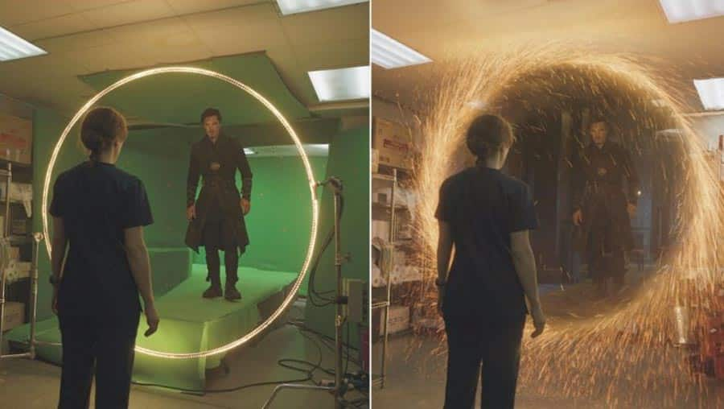

Figure 4: Composting in Film

Chroma Keying: Chroma keying, also known as green screen or blue screen, is a technique where a specific color (usually green or blue) is replaced with another image or footage during post-production. This allows filmmakers to place actors or objects in different environments or settings that may be difficult or impossible to film on location. It is commonly used for creating fantastical or otherworldly backgrounds.

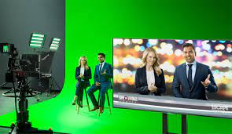

Figure 5: Chroma Keying in news

Motion Tracking: Motion tracking involves analyzing the movement of objects or characters within a scene. This technique is used to accurately track their position, scale, and rotation over time. It enables the seamless integration of computer-generated elements into live-action footage, such as adding CGI characters or objects that interact realistically with the environment.

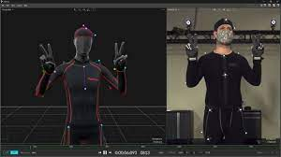

Figure 6: Motion Tracking

1. Rendering and composition: The processed images are rendered and composed together to create the final scene or sequence. This involves combining different layers, adding visual effects, and adjusting the overall look.
2. Post-processing: After rendering, additional post-processing steps may be performed, such as adding film grain, adjusting contrast, or applying filters to achieve the desired artistic style.
3. Output: The final processed images or videos are then ready for distribution, whether it's for movies, TV shows, video games, or other forms of entertainment.

Image processing plays a crucial role in creating captivating visual experiences in the entertainment industry by pushing the boundaries of what is visually possible and enhancing the overall quality of the content.

**1.2, The gaming industry in image processing**

The gaming industry heavily relies on image processing to create realistic graphics, improve game physics, and enhance the overall gaming experience. Image processing techniques are used for tasks such as rendering 3D models, applying textures and lighting effects, motion capture for character animations, and image recognition for augmented reality games. These technologies contribute to the immersive and visually stunning experiences in the gaming industry.

These technologies contribute to the immersive and visually stunning experiences in the gaming industry.

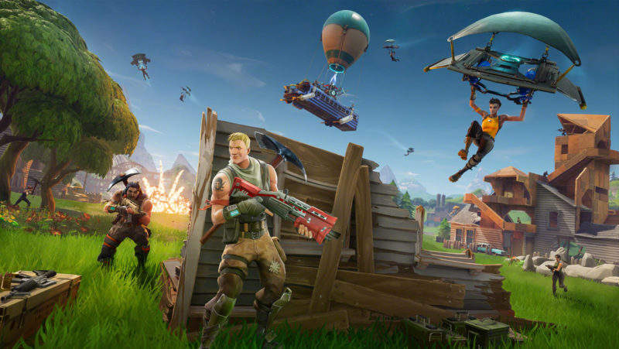

Figure 7: gaming industry

**How does image processing work in the gaming industry?**

In the gaming industry, image processing involves the manipulation and enhancement of images to create realistic graphics and improve the overall gaming experience.

Here's a simplified overview of how image processing works in the gaming industry:

1. Creating 3D models and textures: Game developers create 3D models of characters, objects, and environments, along with textures that define their appearance including details like color, surface texture, and lighting.

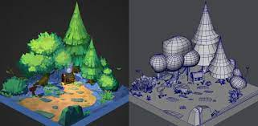

Figure 8: Creating 3D models and textures

1. Rendering: is the process of creating images or frames from 3D models, textures, and other visual elements to display on the screen in real-time.

Modern game engines use various rendering techniques such as rasterization or ray tracing to create realistic and visually appealing graphics. Game developers optimize rendering performance by using techniques like LOD rendering, occlusion culling, and optimization algorithms to ensure smooth and responsive gameplay.

1. Physics simulation: Image processing techniques are used to simulate physics, such as the movement of objects, collisions, and destruction.

A, Movement of Objects: Image processing algorithms can simulate the movement of objects in a game. This includes determining their position, velocity, and acceleration over time. By applying physics principles, such as Newton's laws of motion, game developers can create realistic movements for objects like characters, vehicles, or projectiles.

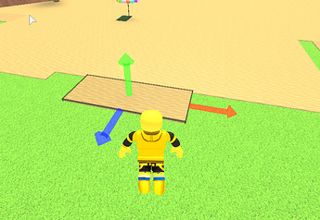

Figure 9: object movement simulation

B, Collisions: Image processing is used to detect and handle collisions between objects in a game. By analyzing the positions and shapes of objects, algorithms can determine when they intersect or come into contact with each other. This allows for realistic reactions and interactions between objects, such as bouncing off surfaces, causing damage, or triggering specific events.



Figure 10: Collision simulation

Destruction: Image processing techniques can be used to simulate the destruction or deformation of objects in a game. This involves breaking apart or altering the shape of objects based on factors like impact force, material properties, and collision dynamics. By using physics-based algorithms, game developers can create visually impressive destruction effects that enhance the realism and immersion of gameplay.

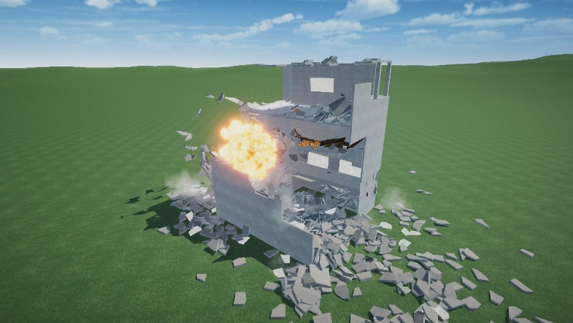

Figure 11: Destruction of the objects simulation

1. Motion capture: Motion capture technology is used to record the movements of actors or athletes, which are then applied to 3D models to create realistic character animations.

A, Recording: Motion capture systems use cameras or sensors to record the movements of actors or athletes as they perform specific actions or movements. These movements are captured as 3D data points, which are then used to create animations for virtual characters in games.

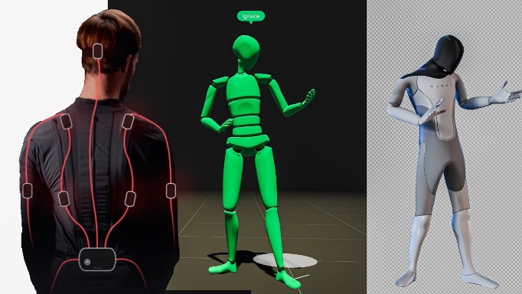

Figure 12: Capturing or recording the motion through the sensors

B, Processing: The data captured during motion capture is processed using specialized software that applies the captured movements to 3D models of characters. This process involves mapping the movements of the actors to the virtual characters and adjusting for differences in body proportions and other factors.

C, Integration: Once the motion capture data is processed, it is integrated into the game engine to create realistic character animations. This includes movements like walking, running, jumping, and combat actions, which are all based on real-world movements captured during motion capture.

*Figure 13:* Realistic character animation of jumping

1. Image recognition: Image recognition is used for augmented reality games, where real-world objects are recognized and augmented with virtual content.

Here's how it works:

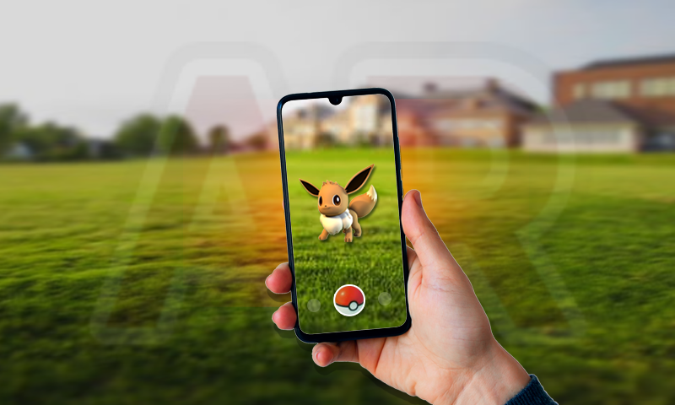A, Recognition: Image recognition algorithms are used to detect and identify real-world objects, such as markers or images that are used as triggers for AR content. These objects are recognized by analyzing their visual features, such as color, shape, and texture.

### Figure 13: Augmented reality game called Pokémon GO

B, Augmentation: Once the real-world object is recognized, AR content is overlaid onto the object using specialized software. This can include 3D models, animations, or other visual elements that appear to interact with the real-world object.

C, Interaction: The player can interact with the AR content by moving the real-world object or interacting with the virtual elements overlaid on it. This creates a unique and immersive gameplay experience that combines the real and virtual worlds.

1. Post-processing: After rendering, additional post-processing steps may be performed, such as adding depth of field, motion blur, or color grading to achieve the desired visual style.
2. Output stage: The final processed images or videos are then displayed on the user's screen, providing an immersive and visually stunning gaming experience.

Here's how it works:

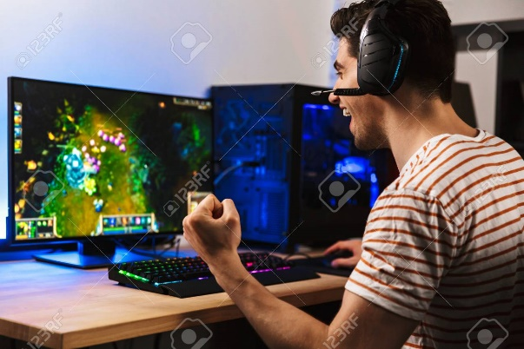

A, Display: The game engine renders the final frames or images based on the processing of 3D models, textures, physics simulations, and other game elements. These frames are then sent to the user's screen for display.

Figure 14: playing video game on a computer

B, Immersion: The output stage aims to create an immersive experience for the player. This includes providing high-quality graphics, realistic animations, and special effects to enhance the visual appeal of the game.

C User Interface: The output stage also includes displaying user interfaces, such as menus, HUD (heads-up display), and other on-screen elements that provide information and allow interaction with the game.

D Optimization: Game developers optimize the output stage to ensure smooth and responsive gameplay. This involves managing frame rates, resolution, and other graphical settings to balance visual quality with performance.

Image processing is a critical component of modern gaming, enabling game developers to create increasingly realistic and visually stunning games that push the boundaries of what is possible.